Hypothesis
- Most of the sales occur in Medina and mecca due to their being holy cities.
- Most of the revenue will be generated from retail customers.
- In mecca and medina, most of the sales will be from new customers.
- In mecca and madina, most of the sales will be on Friday, due to most peoples try to visit holy cities for prayers.
- Most of the sales will be from store due to being data from 2020-2022 which is not of very advanced world.
- In most of the cases, customer satisfaction level will be normal (OK).
Business questions to answer
- Month wise sales (combined month of all years)
- Most selling day (like Monday, Sunday etc).
- Most selling year
- From which city most of the revenue is generated.
- Which are the most revenue generating products?
- Which gender makes more orders?
- The no of orders received by each employee.
- The no of orders received by each manager.
- Create a slicer for a manager.
- Most revenue generating product category?
- Most selling product category by no of orders?
- Most of the orders occurred through which medium/channel.
- The most favorite channel of top most gender is?
- What is the most common customer satisfication level?
- For which product categories, the customer satisfactions is very high
- For which product categories, the customer satisfactions is very low.
- Customer satisfaction levels for each manager.
- Total Sales of each employee, manager and product category.
- Which is the most common customer type
- Which are the top 3 customers in each customer type(by number of orders they make)
- Revenue generated from each customer type.
- In which city most and least of transactions occurred, also create a slicer of city.
KPIs
Total Products: 100
Total Product Categories: 10
Total Customers: 26
Total Employees: 6
Total Managers: 2
Total Orders: 49998
Total Sales: 98.65M
Total Cities: 12
Employee to Customer Ratio= 1:4
Manager to Employee Ratio= 1:3

Analysis and Visualizations
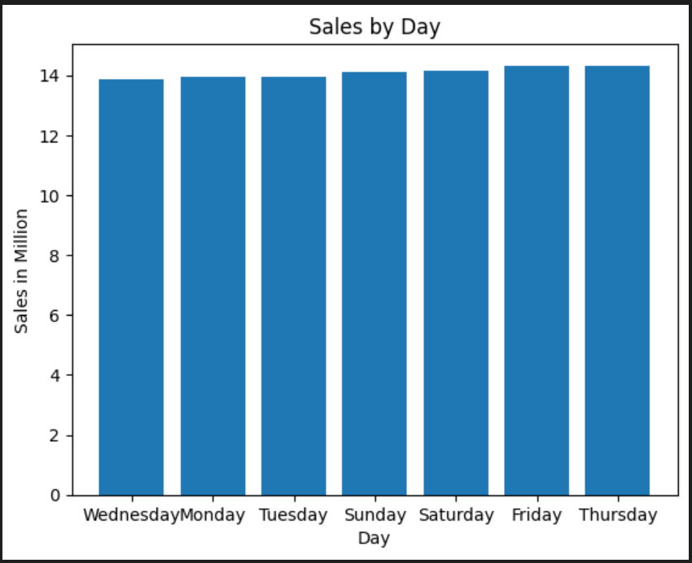
The diagram shows that most of the sales occurred on Thursday and Friday while the Wednesday is the day when least sales happened.
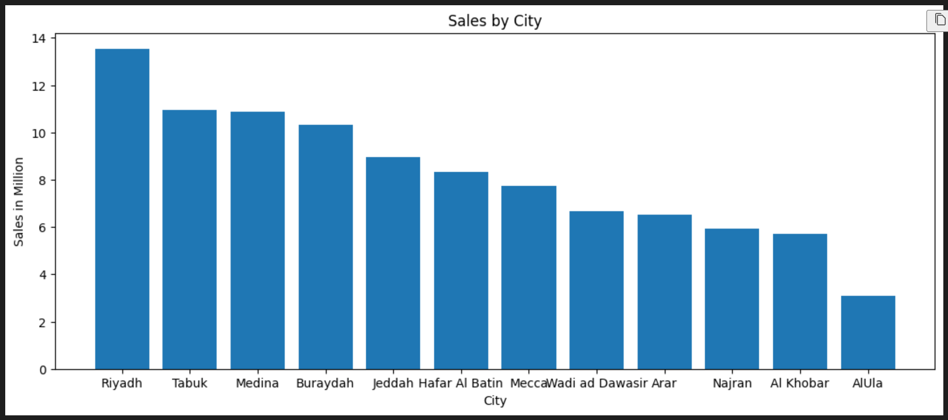
This chart demonstrates the revenue generated from each city mentioned in the dataset.
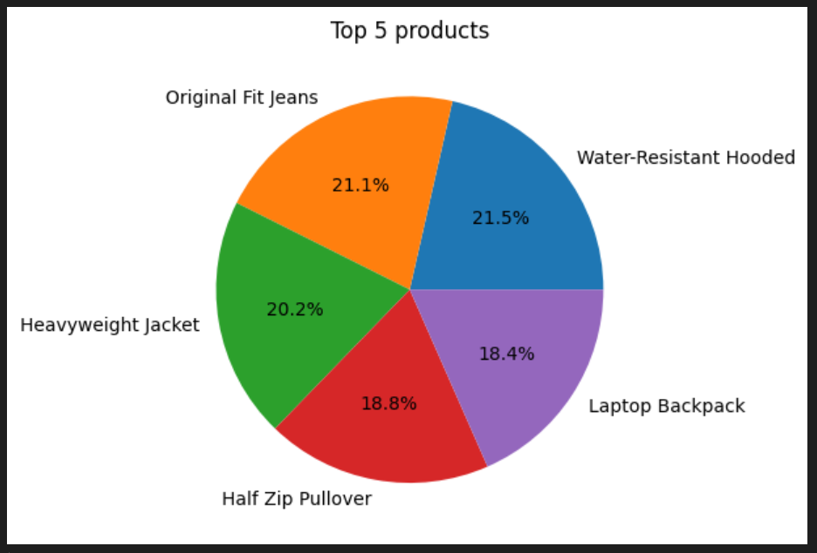
This chart shows the top 5 products with respect to revenue generated from each product. If we combine the sales of top 5 products , then the contribution of each product in the combined sales is show above.
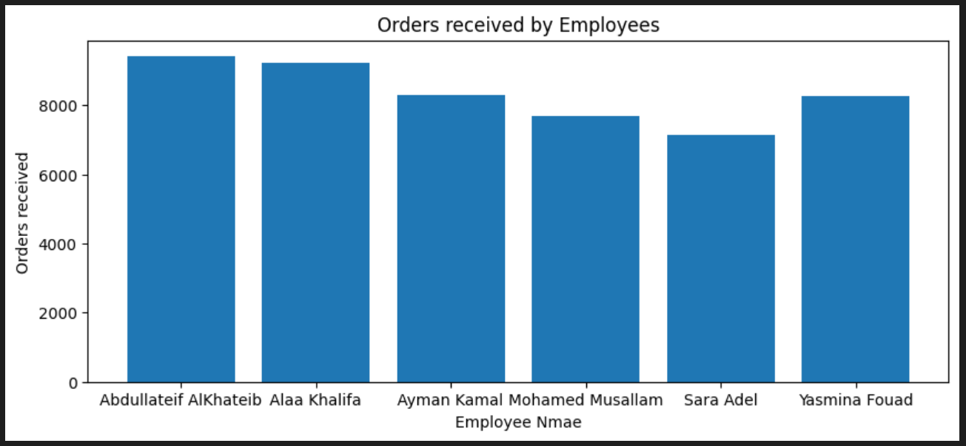
This chart shows the orders completed by each employee out of total orders. There are only 6 employees mentioned in the dataset.
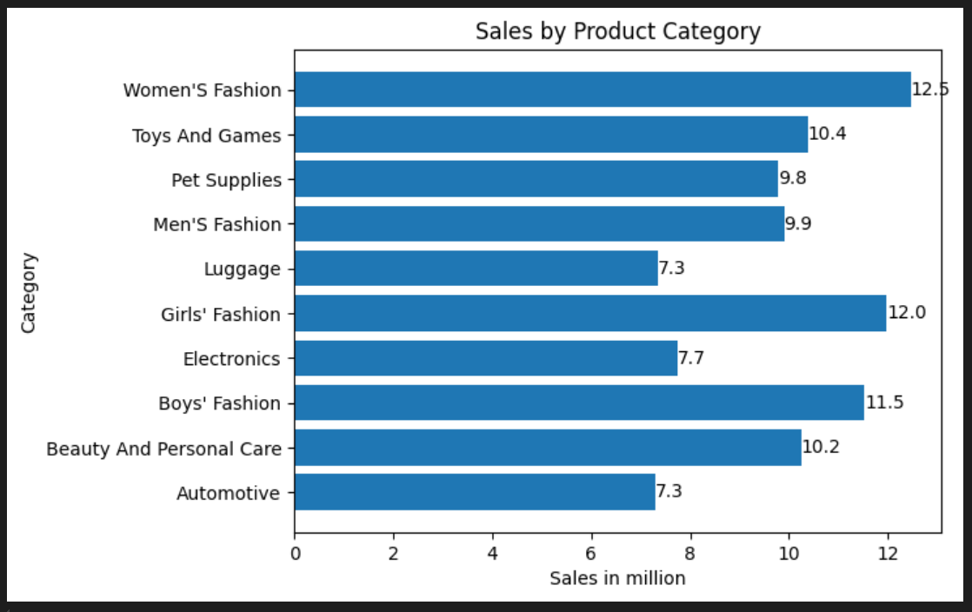
This charts shows the sales of each product Category in four years. The sales are shown in millions. Each product category sales is more than 1 million.
Insights
The employee “abdul latif alkhatib” is performing very well, so he should be awarded and Sara Adel who doesnot perform well should be encouraged to get and complete more orders.
The automotive sector is not performing well compared to other product categories. Increase its sales
Women’s fashion is the category that generates highest revenue.
The average customer satisfaction level is high showing the overall best performance of stores.
The product category “Beauty and personal care” got high number of “very high” satisfaction ratings, showing that this category is performing well.
Women’s fashion, the highest revenue generating category also gets the high number of “very low” satisfaction level.
Most of the revenue is generated from loyal customers, so the stores ensures the loyal customers are satisfied.
Hypothesis Verification
- Most of the sales occur in Riyadh and Tabuk, not in Mecca and Medina: False
- Most of the revenue is generated from Loyal Customers, not from retail ones: False
- In Mecca and Medina, Most of the sales are from loyal customers and least from new customers: False
- In Mecca and Medina, most of the sales are on Saturday, not Friday. Both by store and online: False
- Most of the sales are online not offline (store): False
- The customer satisfaction level for most of the tasks is High: False
Note: All hypothesis proved wrong

